SHORT-TERM INTERNSHIP

Name of the Student: TIRUVAYEPATI HARSHI

Name of the College: SRK INSTITUTE OF TECHNOLOGY

Registration Number:23X41A4462

Period of Internship: 2MONTHS From:12-05-2025 To:11-07-2025

Name & Address of the Intern Organization: BIST TECHNOLOGIES

An Internship Report On

MOVIE RECOMMENDATION SYSTEM

Submitted in accordance with the requirement for the degree of

BACHELOR OF TECHNOLOGY

In

COMPUTER SCIENCE AND ENGINEERING (DATA SCIENCE)

Submitted by

23X41A4462

Under the faculty guidance of

D.S.V. Gowtham



DEPARTMENT OF

COMPUTER SCIENCE AND ENGINEERING(DATA SCIENCE)

S.R.K INSTITUTE OF TECHNOLOGY

Enikepadu, Vijayawada, Krishna-521108

(AUTONOMOUS)

An Institute Accredited by NBA & NAAC with ‘A’ Grade

July 2025

STUDENT DECLARATION

I, TIRUVAYEPATI HARSHI, student of SRK Institute of technology, Registration. No. 23X41A4462 of the Department of C.S.E. DATA SCIENCE, do hereby declare that I have completed the mandatory internship on DATA SCIENCE INTERNSHIP from 11.05.2025 to 12.07.2025 in BIST TECHNOLOGIES DATA SCIENCE INTERNSHIP PROGRAM under the Faculty Guide ship of Department of CSE DATA SCIENCE, SRK Institute of Technology.

(Signature and Date)

OFFICIALCERTIFICATION

This is to certify that the, Registration. No. 23X41A4462 has completed Internship in EduSkills Cohort Virtual Internship on DATA SCIENCE INTERNSHIP under my supervision as a part of partial fulfillment of the requirement for the Degree of B. Tech CSE DATA SCIENCE, SRK Institute of Technology. This is accepted for evaluation.

Endorsements

Supervisor

Head of the Department

Principal

ACKNOWLEDGEMENTS

Firstly, I would like to convey my heartfull thanks to the almighty for the blessings on me to carry on this internship work without any disruption.

I am extremely thankful to D.S.V. Gowtham internship Guide who guided me throughout the internship. I am thankful to his forgiving me the most independence and freedom throughout various phases of the internship.

I am very much grateful to Dr V. Sreenivas, H.O.D of C.S.D Department, for his valuable guidance which helped me to bring out this internship successfully. His wise approach made me to learn the minute. Details of the project. His matured and patient guidance paved a way for completing our internship with the sense of satisfaction and pleasure.

I am very much thankful to our principal Dr. K. RAMESH for his kind support and facilities provided at our campus which helped me to bring out this internship successfully.

Finally, I would like to convey my heart full thanks to all technical Staff, for his guidance and supporting every step of this internship. I convey my sincere thanks to all the faculty and friends who directly or
indirectly helped me for the successful completion of this internship

CONTENTS

Page No.
- Chapter1……………………………………………………………………… 01-02
Introduction
- Chapter2……………………………………………………………………….03
Monthly Overview
- Chapter3………………………………………………………………………04-42
Modules
- Chapter4……………………………………………………………………..43-46
Proposed Methodology
- Chapter5……………………………………………………………………47-48
Result and Conclusions
- Chapter6………………………………………………………………………..49
Verifiable Credentials
References

ABSTRACT

The Movie Recommendation System is an AI-based project designed to suggest movies to users based on their preferences, viewing history, and similarity to other users or movies. The system utilizes data science and machine learning techniques to analyze datasets containing movie details such as genre, ratings, cast, and user feedback. By applying algorithms like content-based filtering, collaborative filtering, or a hybrid approach, the model predicts which movies a user is most likely to enjoy.

The main goal of this project is to enhance the user experience by providing personalized recommendations, similar to platforms like Netflix or IMDb. The system is built using Python, with data stored and queried using SQL, and libraries such as Pandas, NumPy, Scikit-learn, and Streamlit/Flask for model implementation and visualization.

This system utilizes collaborative filtering, content-based filtering, and hybrid approaches to analyze user behavior, movie metadata, and ratings. By integrating machine learning algorithms and user interaction data, the system predicts and recommends movies that users are likely to enjoy. It enhances user experience by reducing search time, increasing engagement, and personalizing content delivery.

The system can be deployed across streaming platforms, mobile apps, and websites, offering scalable and adaptive recommendations based on evolving user preferences. This project demonstrates the practical application of artificial intelligence in entertainment, showcasing how intelligent systems can transform passive browsing into an active, personalized discovery experience.

CHAPTER-1
INTRODUCTION
Suggestion frameworks square measure the frameworks that square measure used to accumulate shopper fascination by understanding the client's style. These frameworks have currently become thought because of their capability to allow customised substance to shoppers that square measure of the client's advantage. Nowadays an outsized range of things square measure recorded on net business sites that create it tough to get a results of our ideal call. This is often the place wherever these frameworks assist United States by apace suggesting United States with the perfect things. Proposal frameworks facilitate shoppers notice and choose things (e.g., books, motion photos, eateries) from the big variety accessible on the online or in different electronic knowledge sources. Given a massive arrangement of things and a portrayal of the client's needs, they gift to the consumer a bit arrangement of the items that square measure applicable to the depiction. Also, a movie proposal framework provides a degree of solace and personalization that assists the consumer with collaborating the framework and watch motion photos that take into consideration his needs. Giving this degree of solace to the consumer was our essential inspiration in choosing film proposal framework as our BE Project. The most reason for our framework is to impose motion photos to its shoppers obsessed with their review history and evaluations that they provide. The framework can likewise impose totally different E-trade organizations to advertise their things to specific shoppers obsessed with the categoryof films they like. Made-to-order proposal motors facilitate a large variety of people slender the universe of doubtless movies to accommodate their exceptional tastes. Community separating and content based mostly winnow square measure the square measure prime ways in which to traumatize provide suggestion to shoppers. The 2 of them square measure best relevant in specific things in light-weight of their explicit smart and dangerous times. During this paper we've projected a emulsified methodology with the tip goal that each the calculations supplement one another consequently rising presentation and exactness of the of our framework.

1.1 RELATED WORK
Film proposals utilizing a number of procedures are widely targeted within the previous a few years. Models incorporate a proposal framework utilizing the ALS calculation, a suggestion smitten by the coefficient procedure, thing likeness based mostly synergistic separation. These procedures would like earlier information regarding the appraisals for the motion photos that square measure made by the shopper. These strategies significantly use film attentiveness datasets for assessment functions. Nonetheless, these frameworks aren't somewhat actual, and analysis is continuous to boost the continuing exhibition of those frameworks. Style and Implementation of cooperative Filtering Approach utilizing KNN Cui, Bei-Bei[2] has self-addressed the suggestion framework Utilizing the rating and likeness among the 2 clients; the framework prescribes an issue to the shopper for the dynamic. At that time separate the film informational index into Associate in nursing unrated and evaluated take a look at set with the help of the KNN model. It will counsel the motion photos to the obscure shoppers through shopper tour of duty information, furthermore, it will create new and not thought film suggestions as indicated by the film's set of experiences and score. The info set during this approach is that the MYSQL data base. The tour of duty framework for a shopper can snap the client's outer and interior conduct qualities, and these attributes square measure place away within the shopper information base through a login module for the shopper. The to a lower place figure1.Portrays their compelling technique of approach for a collective sifting approach utilizing KNN. Comparison with completely different calculations. In [4], Goutham Miryala projected an identical investigation of ALS on completely different calculations. still, it's seen that utilizing a additional broad making ready dataset of 80-20 (Training - Testing) yields a model that includes a lower RMSE once contrasted with the 60-40 (Preparing - Testing) dataset. The result shows that the upper regularization boundary expands RMSE and therefore the different method around. The ALS calculation is contrasted and SVD, KNN, and Normal Indicator, and therefore the outcomes show that ALS is that the best calculation for the suggestion framework.

CHAPTER-2
WEEKLY OVERVIEW

S.NO | WEEKS | CHAPTERS
1. | 1st Week | Introduction to Data Science & Machine Learning  Fundamentals of Python Programming
2. | 2nd Week | Introduction to Supervised Learning  Regression & Classification Techniques
3. | 3rd Week | Unsupervised Learning Concepts  Clustering & Dimensionality Reduction
4. | 4th Week | Model Evaluation Methods  Cross-Validation Techniques
5. | 5th Week | Performance Metrics for Regression & Classification
6. | 6th Week | Fundamentals of Deep Learning  Types of Neural Networks
7. | 7th Week | Project Development & Implementation
8. | 8th Week | Final Project Submission & Review

CHAPTER-3
INTRODUCTIONTO DATA SCIENCE
Data Science is an interdisciplinary field that uses scientific methods, processes, algorithms, and systems to extract knowledge and insights from structured and unstructured data. It combines elements from statistics, computer science, mathematics, and domain knowledge to analyze and interpret complex data. Data Science turns raw data into actionable insights that help solve real-world problems and support better decision-making.
At its core, data science involves understanding data in depth, analyzing patterns, making predictions, and providing actionable insights that support business strategies and innovations. Data scientists work with large amounts of structured and unstructured data, using advanced analytics techniques including machine learning, data mining, and predictive modeling.
Importance of Data Science
In today’s digital age, data is generated at an unprecedented rate — through social media, transactions, sensors, mobile devices, and more. This explosion of data has created both an opportunity and a challenge. The opportunity lies in the potential insights hidden within this data, which can be used to drive growth, enhance customer experience, and innovate products and services. The challenge is how to process, manage, and make sense of such large and diverse datasets.
Data science bridges this gap by providing methods and tools to turn raw data into valuable insights. It helps companies:
- Identify trends and patterns
- Understand customer behavior
- Improve operational efficiency
- Detect fraud or risks
- Make accurate predictions
- Develop data-driven strategies
Key Components of Data Science
Data science follows a systematic approach that includes several essential steps:

1. Data Collection
Data scientists collect data from various sources like web servers, APIs, IoT devices, surveys, and internal databases. This data can be structured (like tables) or unstructured (like text, images, and videos).

2. Data Cleaning and Preparation
Raw data often contains errors, missing values, or inconsistencies. This step involves cleaning and transforming data into a format suitable for analysis. Techniques like normalization, encoding, and imputation are commonly used.

3. Exploratory Data Analysis (EDA)
EDA is the process of visually and statistically exploring the dataset to understand its main characteristics. Data scientists use graphs, charts, and summary statistics to identify patterns, anomalies, and relationships.

4. Feature Engineering
This involves selecting or creating relevant features (variables) from raw data that can improve the performance of machine learning models. It is one of the most critical and creative parts of data science.

5. Model Building
Once the data is ready, machine learning algorithms are applied to build predictive models. Common algorithms include linear regression, decision trees, support vector machines, and neural networks. Models are trained using historical data and then evaluated using unseen data.

6. Model Evaluation and Tuning
Models are assessed using metrics such as accuracy, precision, recall, F1-score, or RMSE (Root Mean SquaredError), depending on the type of problem (classification, regression, etc.). Hyperparameters are tuned to optimize model performance.

7. Deployment
After a model is validated, it is deployed into a production environment where it can be used by applications or users. Tools like Flask, Docker, or cloud services (AWS, Azure, Google Cloud) are used for deployment.

8. Monitoring and Maintenance
Models need to be monitored for performance over time. As new data comes in, the model may need to be retrained or updated to maintain accuracy.

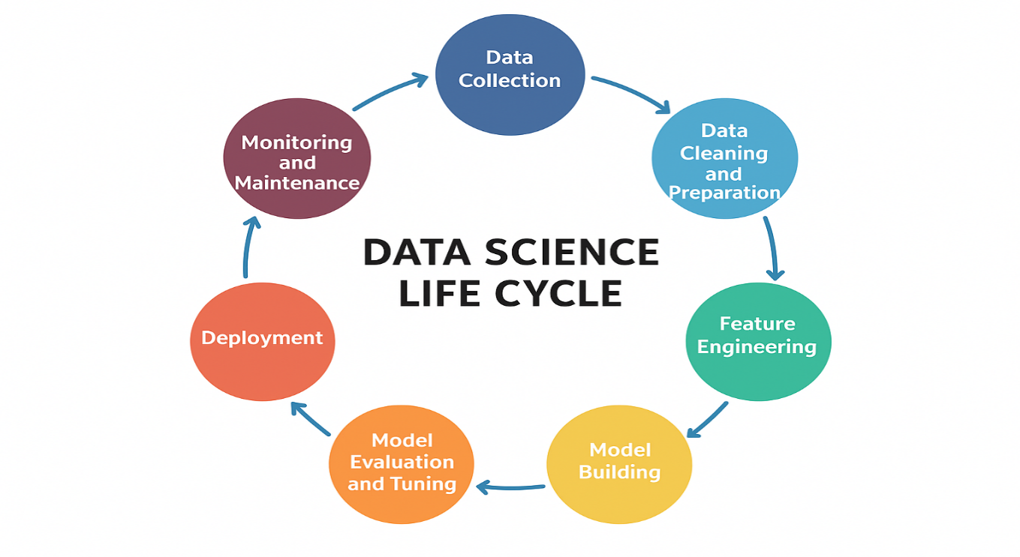

Tools and Technologies in Data Science
Data scientists use a variety of tools and programming languages to perform their tasks effectively:
- Programming Languages: Python, R, SQL, Scala
- Data Manipulation Libraries: Pandas, NumPy
- Visualization Tools: Matplotlib, Seaborn, Tableau, Power BI
- Machine Learning Libraries: Scikit-learn, TensorFlow, Keras, PyTorch
- Big Data Technologies: Hadoop, Apache Spark
- Databases: MySQL, PostgreSQL, MongoDB
- Cloud Platforms: AWS, Google Cloud Platform (GCP), Microsoft Azure
- Notebooks: Jupyter, Google Colab
Python is one of the most popular languages in data science due to its simplicity and the vast ecosystem of libraries it supports.
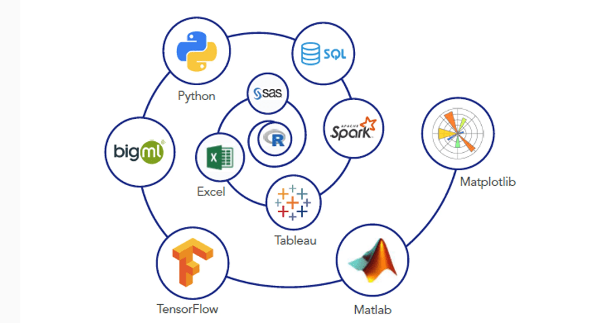
Applications of Data Science
Data science is widely used across industries to solve a variety of real-world problems:
- Healthcare
- Predict disease outbreaks
- Personalized medicine
- Medical image analysis
- Hospital resource optimization

- Finance
- Fraud detection
- Risk assessment
- Credit scoring
- Algorithmic trading

- Retail and E-commerce

- Recommendation systems
- Customer segmentation
- Price optimization
- Inventory management

- Transportation

- Route optimization
- Traffic prediction
- Self-driving technology

- Manufacturing

- Predictive maintenance
- Quality control
- Supply chain optimization

Sports & Entertainment
- Injury prediction & prevention.
- Game strategy optimization.
- Music/movie recommendation systems (Spotify, YouTube).

Space & Astronomy
- Analyzing satellite images.
- Detecting exoplanets & galaxies.
- Predicting asteroid collisions.

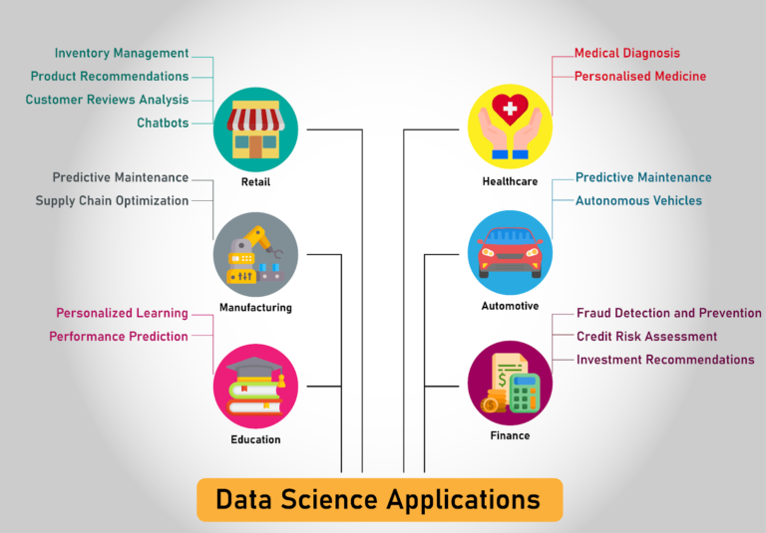

Machine Learning in Data Science
Machine Learning (ML) plays a crucial role in Data Science by enabling systems to learn from data and make intelligent decisions or predictions without being explicitly programmed. It forms the analytical core of data science, enabling data scientists to extract deeper insights, recognize patterns, and build predictive models from massive amounts of data.
Here’s how ML enhances and powers data science tasks:
1. Pattern Recognition
Machine learning identifies patterns and relationships within large datasets that are often invisible to the human eye. These patterns are essential for building predictive models in data science.
Example: Identifying customer buying patterns to recommend products.
2. Predictive Analytics
ML models can forecast future outcomes based on historical data. This is a key part of data science, especially in business forecasting, demand planning, and risk assessment.
Example: Predicting stock prices, sales trends, or disease outbreaks.
3. Automation of Analysis
ML automates complex data analysis tasks. This allows data scientists to focus on strategy and interpretation rather than repetitive tasks.
Example: Automatically classifying emails as spam or not.
4. Improved Accuracy and Scalability
Machine learning models improve over time as they process more data, increasing the accuracy of predictions. They also scale well to handle massive datasets.
Example: Recommendation systems on Netflix or Amazon.
5. Classification and Clustering
ML algorithms help group data (clustering) or label data into categories (classification), which is a major step in many data science projects.
Example: Classifying customer feedback as positive, negative, or neutral.
6. Feature Selection and Engineering
Machine learning assists in selecting the most important features (variables) from a dataset, improving model performance and reducing complexity.
Example: Choosing the best factors that influence house prices.
7. Real-Time Decision Making
ML models can be deployed in real-time systems to provide instant decisions based on live data.
Example: Fraud detection in banking transactions.
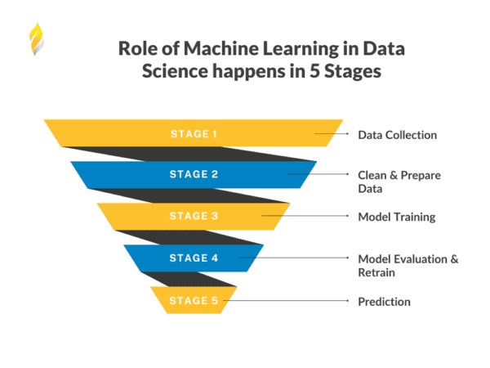
Introduction to Machine Learning
Machine learning, a vital subfield of artificial intelligence, focuses on crafting algorithms and statistical models that empower computers to enhance their performance through experience. These models are engineered to learn from data, enabling them to make predictions or decisions without explicit instructions. Various types of machine learning exist, including supervised, unsupervised, and reinforcement learning. In supervised learning, models are trained on labeled data, while unsupervised learning involves training on unlabeled data. Reinforcement learning, on the other hand, relies on trial and error for training. Machine learning finds applications across diverse domains such as image and speech recognition, natural language processing, and recommender systems.
At its core, machine learning algorithms develop mathematical models that facilitate predictions or decisions without explicit programming, leveraging historical data or training data. This amalgamation of statistics and computer science enables the creation and utilization of algorithms that learn from past data. Importantly, the performance of these algorithms improves in tandem with the quantity and quality of the information provided.
How does Machine Learning work
A machine learning system builds prediction models, learns from previous data, and predicts the output of new data whenever it receives it. The amount of data helps to build a better model that accurately predicts the output, which in turn affects the accuracy of the predicted output.
Let's say we have a complex problem in which we need to make predictions. Instead of writing code, we just need to feed the data to generic algorithms, which build the logic based on the data and predict the output. Our perspective on the issue has changed as a result of machine learning. The Machine Learning algorithm's operation is depicted in the following block diagram:

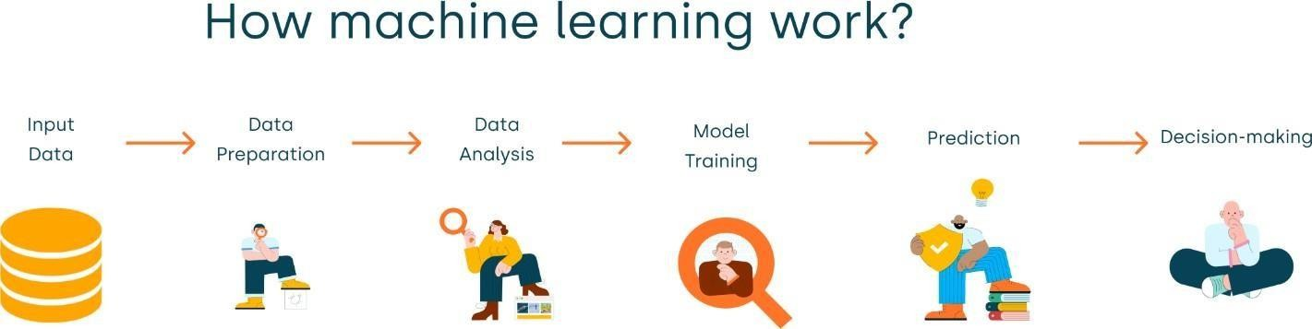

Classification of Machine Learning
At a broad level, machine learning can be classified into three types:
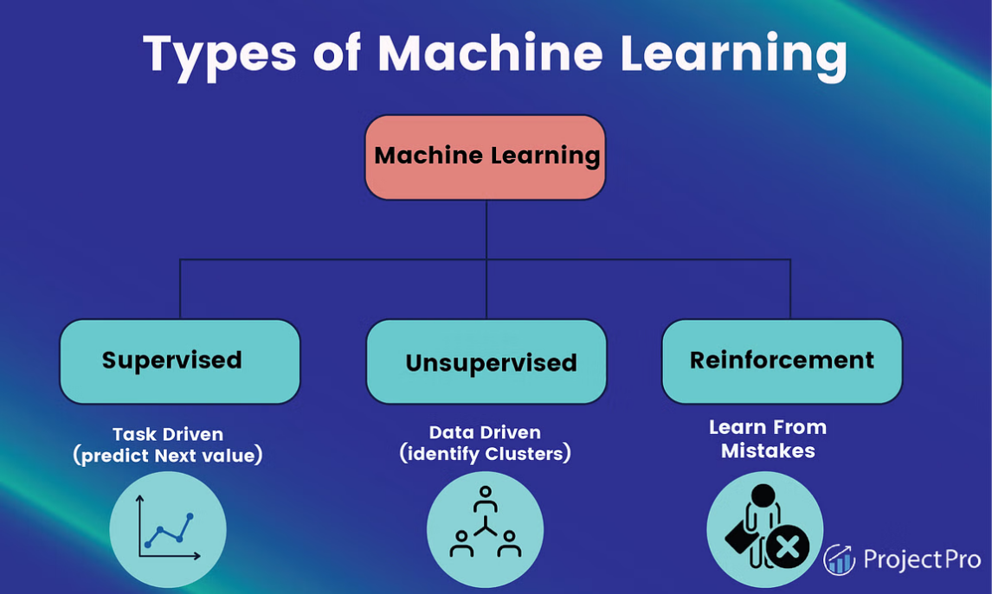
1. Supervised Learning
In supervised learning, sample labelled data are provided to the machine learning system for training, and the system then predicts the output based on the training data. The system uses labeled data to build a model that understands the datasets and learns about each one. After the training and processing are done, we test the model with sample data to see if it can accurately predict the output.
The mapping of the input data to the output data is the objective of supervised learning. The managed learning depends on oversight, and it is equivalent to when an understudy learns things in the management of the educator. Spam filtering is an example of supervised learning.
Supervised learning can be grouped further in two categories of algorithms:
- Classification
- Regression
2. Unsupervised Learning
Unsupervised learning is a learning method in which a machine learns without any supervision.
The training is provided to the machine with the set of data that has not been labeled, classified, or categorized, and the algorithm needs to act on that data without any supervision. The goal of unsupervised learning is to restructure the input data into new features or a group of objects with similar patterns.
In unsupervised learning, we don't have a predetermined result. The machine tries to find useful insights from the huge amount of data. It can be further classifieds into two categories of algorithms:
- Clustering
- Association

3. Reinforcement Learning
Reinforcement learning is a feedback-based learning method, in which a learning agent gets a reward for each right action and gets a penalty for each wrong action. The agent learns automatically with these feedbacks and improves its performance. In reinforcement learning, the agent interacts with the environment and explores it. The goal of an agent is to get the most reward points, and hence, it improves its performance.
The robotic dog, which automatically learns the movement of his arms, is an example of Reinforcement learning.
Machine Learning Problem Categories:
- Classification:
- Classification is a type of supervised learning technique used to predict the class or category of a new observation based on labeled training data.
- Classification is a way to identify a grouping technique for a given dataset in such away that depending on a value of the target or output attribute, the entire dataset can be qualified to belong to a class.
- This technique helps in identifying the data behavior patterns. This is, in short, a discrimination mechanism.
- For example, a spam filter is a common example of classification, where the algorithm is trained to classify an email as spam or not spam based on previous labeled examples.
Examples:
- Email spam filtering: Classifying emails as either spam or not spam based on the contents of the email.
- Image classification: Identifying objects in an image and labeling them according to their category (e.g., dog, cat, bird, etc.).
- Fraud detection: Identifying whether a transaction is fraudulent or legitimate based on historical data and other factors.
- Clustering:
- Clustering is an unsupervised learning technique used to group similar observations into clusters based on their features or attributes.
- The goal of clustering is to identify natural groupings within the data that can be used to gain insights or make predictions.
- In short, clustering is a classification analysis that does not start with a specific target in mind (good/bad, will buy/will not buy).
- For example, clustering can be used to group customers based on their purchasing behavior, or to group patients based on their health status.
Examples:
- Customer segmentation: Grouping customers with similar purchase patterns together to better understand their behavior.
- Image segmentation: Separating an image into different regions based on their similarity or dissimilarity.
- Anomaly detection: Identifying unusual patterns or behaviors in data, such as identifying a defective product in a manufacturing line.
- Regression:
- Regression is a type of supervised learning in which an algorithm learns to predict a continuous numerical value or output based on a set of input features.
- The goal of regression is to create a model that accurately predicts the output value of new, unseen data. For example, in housing price prediction, regression can be used to predict the price of a house based on features such as its location, size, and number of rooms.
Examples:
- Housing price prediction: Predicting the price of a house based on its location, size, and other features.
- Stock market prediction: Predicting the future price of a stock based on its historical performance and other factors.
- Medical diagnosis: Predicting a patient’s future health status based on their medical history and other factors.
- Simulation:
- Simulation is a technique used to generate synthetic data based on a set of assumptions and rules.
- Simulations can be used to model complex systems or processes that are difficult or expensive to study in the real world.
- For example, in traffic simulation, a computer model can be used to simulate traffic patterns and optimize traffic flow through a city.
- Similarly, climate modeling can be used to simulate the Earth’s climate and predict future climate patterns.
Examples:
- Traffic simulation: Simulating traffic patterns to better understand how traffic flows through a city and to optimize traffic flow.
- Climate modeling: Simulating the Earth’s climate to better understand the effects of climate change and to predict future climate patterns.
- Financial risk modeling: Simulating different financial scenarios to better understand risk and to make informed investment decisions.

- Optimization:
- Optimization is a technique used to find the best solution to a problem, given a set of constraints and objectives.
- Optimization problems can involve maximizing or minimizing an objective function subject to certain constraints.
- For example, in supply chain optimization, the goal is to optimize the logistics of a supply chain to reduce costs and improve efficiency.
- Portfolio optimization is another example in which the goal is to optimize the allocation of investments to maximize returns while minimizing risk.
- Resource allocation is yet another example in which the goal is to optimize the allocation of resources, such as personnel, time, and equipment, to maximize efficiency and minimize costs.
Fundamentals of Python Programming
Python is a high-level, interpreted, and general-purpose programming language. It is known for its simple syntax, readability, and flexibility, making it one of the most popular programming languages in the world. Python supports multiple programming paradigms, including procedural, object-oriented, and functional programming.
It is widely used in web development, data science, machine learning, artificial intelligence, automation, and software development. Leading technology companies like Google, Amazon, Facebook, Instagram, Dropbox, and Uber rely on Python for their products and services.

- Variables: In Python, variables are used to store data values. You can assign a value to a variable using the assignment operator ‘=’.
For example:
age = 25
language = "Python"
print("Age:", age)
print("Language:", language)

- Data Types: Python has several built-in data types including:
- Integers (int): Whole numbers, e.g., 5, -3, 100.
- Floats (float): Decimal numbers, e.g., 3.14, -0.001, 2.0.
- Strings (str): Ordered sequence of characters, e.g., "hello", 'Python', "123".
- Lists (list): Ordered collection of items, e.g., [1, 2, 3], ["apple", "banana", "orange"].
- Tuples (tuple): Ordered, immutable collection of items, e.g., (1, 2, 3), ("apple", "banana", "orange").
- Dictionaries (dict): Key-value pairs, e.g., {"name": "John", "age": 30}.
- Control Structures: Python provides control structures for decision-making and looping:
- Conditional Statements (if, elif, else): Used for decision-making based on conditions. For example:
marks = 85
if marks >= 80:
print("Grade: A")
elif marks >= 50:
print("Grade: B")
else:
print("Grade: C")
- Loops (for, while): Used for iterating over a sequence of items. For example:
for i in range(1, 6):
print("Number:", i)

- Functions: Functions are reusable blocks of code that perform a specific task. You can define your own functions using the def keyword.
For example:
def square(num):
return num * num
print("Square of 6:", square(6))
- Modules and Libraries:
- Modules: Python modules are .py files that consist of Python code. You can import these modules into your script using the import statement.
- Libraries: Libraries are collections of modules. NumPy and Pandas are popular libraries used for numerical computing and data manipulation, respectively.
- NumPy: NumPy provides support for large, multi-dimensional arrays and matrices, along with a collection of mathematical functions to operate on these arrays. You can install it using pip (pip install numpy).
Example usage:
- import numpy as np
array = np.array([2, 4, 6, 8])
print("Mean value:", array.mean())
- Pandas: Pandas is a powerful library for data manipulation and analysis. It provides data structures like Series and DataFrame for working with structured data. You can install it using pip (‘pip install pandas’).
For Example:
#Creating a Numpy Array
import pandas as pd
data = {'Product': ['Pen', 'Book', 'Pencil'], 'Price': [10, 50, 5]}
df = pd.DataFrame(data)
print("Product Details:\n", df)
Supervised Machine Learning
Supervised learning is the types of machine learning in which machines are trained using well "labelled" training data, and on basis of that data, machines predict the output. The labelled data means some input data is already tagged with the correct output.
In supervised learning, the training data provided to the machines work as the supervisor that teaches the machines to predict the output correctly. It applies the same concept as a student learns in the supervision of the teacher.
Supervised learning is a process of providing input data as well as correct output data to the machine learning model. The aim of a supervised learning algorithm is to find a mapping function to map the input variable(x) with the output variable(y).
In the real-world, supervised learning can be used for Risk Assessment, Image classification, Fraud Detection, spam filtering, etc.

How Supervised Learning Works?
In supervised learning, models are trained using labelled dataset, where the model learns about each type of data. Once the training process is completed, the model is tested on the basis of test data (a subset of the training set), and then it predicts the output.
The working of Supervised learning can be easily understood by the below example and diagram:
Suppose we have a dataset of different types of shapes which includes square, rectangle, triangle, and Polygon. Now the first step is that we need to train the model for each shape.
- If the given shape has four sides, and all the sides are equal, then it will be labelled as a Square.
- If the given shape has three sides, then it will be labelled as a Triangle.
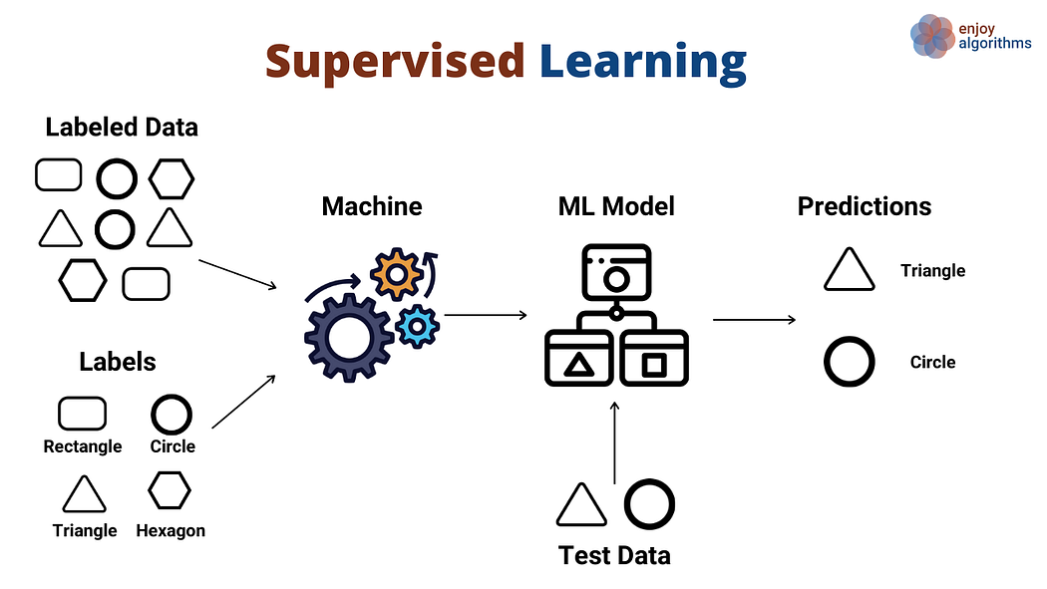
• If the given shape has six equal sides, then it will be labelled as hexagon.
Now, after training, we test our model using the test set, and the task of the model is to identify the shape. The machine is already trained on all types of shapes, and when it finds a new shape, it classifies the shape on the bases of a number of sides, and predicts the output.

Steps Involved in Supervised Learning:
- First Determine the type of training dataset
- Collect/Gather the labelled training data.
- Split the training dataset into training dataset, test dataset, and validation dataset.
- Determine the input features of the training dataset, which should have enough knowledge so that the model can accurately predict the output.
- Determine the suitable algorithm for the model, such as support vector machine, decision tree, etc.
- Execute the algorithm on the training dataset. Sometimes we need validation sets as the control parameters, which are the subset of training datasets.
- Evaluate the accuracy of the model by providing the test set. If the model predicts the correct output, which means our model is accurate.

Types of supervised Machine learning Algorithms:
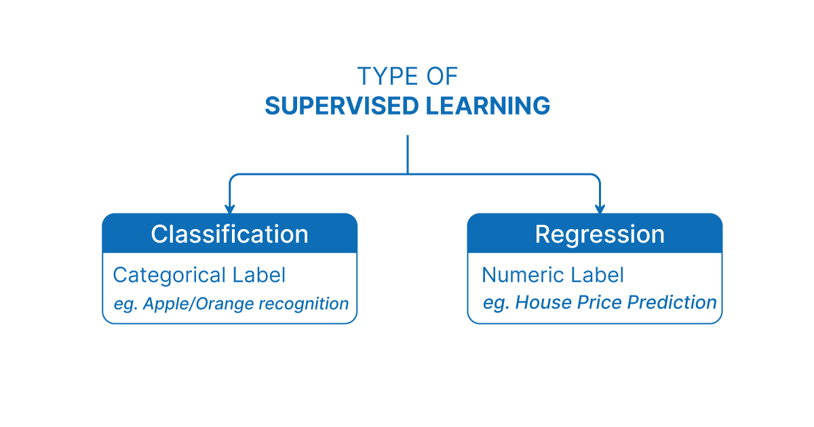Supervised learning can be further divided into two types of problems:
- Regression
Regression algorithms are used if there is a relationship between the input variable and the output variable. It is used for the prediction of continuous variables, such as Weather forecasting, Market Trends, etc. Below are some popular Regression algorithms which come under supervised learning:
- Linear Regression
- Regression Trees
- Non-Linear Regression
- Bayesian Linear Regression
- Polynomial Regression
- Classification
Classification algorithms are used when the output variable is categorical, which means there are two classes such as Yes-No, Male-Female, True-false, etc.
- Random Forest
- Decision Trees
- Logistic Regression
- Support vector Machines
Linear Regression:
Linear regression is one of the easiest and most popular Machine Learning algorithms. It is a statistical method that is used for predictive analysis. Linear regression makes predictions for continuous/real or numeric variables such as sales, salary, age, product price, etc.
Linear regression algorithm shows a linear relationship between a dependent (y) and one or more independent (y) variables, hence called as linear regression. Since linear regression shows the linear relationship, which means it finds how the value of the dependent variable is changing according to the value of the independent variable.
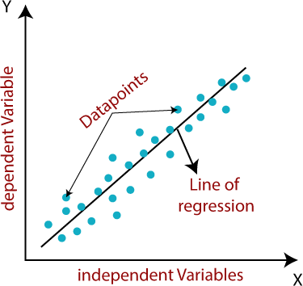
The linear regression model provides a sloped straight line representing the relationship between the variables. Consider the below image:

Mathematically, we can represent a linear regression as:
y= a0+a1x+ ε
Here,
Y= Dependent Variable (Target Variable)
X= Independent Variable (predictor Variable)
a0= intercept of the line (Gives an additional degree of freedom)
a1 = Linear regression coefficient (scale factor to each input value).
ε = random error
The values for x and y variables are training datasets for Linear Regression model representation.
Types of Linear Regression
Linear regression can be further divided into two types of the algorithm:

- Simple Linear Regression:
If a single independent variable is used to predict the value of a numerical dependent variable, then such a Linear Regression algorithm is called Simple Linear Regression.

- Multiple Linear regression:
If more than one independent variable is used to predict the value of a numerical dependent variable, then such a Linear Regression algorithm is called Multiple Linear Regression.
Implementation using Python libraries
Python has methods for finding a relationship between data-points and to draw a line of linear regression. We will show you how to use these methods instead of going through the mathematic formula.
In the example below, the x-axis represents age, and the y-axis represents speed. We have registered the age and speed of 13 cars as they were passing a tollbooth. Let us see if the data we collected could be used in a linear regression:
Example:
import matplotlib.pyplot as plt
x = [5, 7, 8, 7, 2, 17, 2, 9, 4, 11, 12, 9, 6]
y = [99, 86, 87, 88, 111, 86, 103, 87, 94, 78, 77, 85, 86]
plt.figure(figsize=(10,6))
plt.scatter(x, y, color='green', s=100, edgecolor='black', alpha=0.7)
plt.title("Scatter Plot of Sample Data", fontsize=16, fontweight='bold')
plt.xlabel("X Values", fontsize=12)
plt.ylabel("Y Values", fontsize=12)
plt.grid(True, linestyle='--', alpha=0.5)
plt.show()

Output:
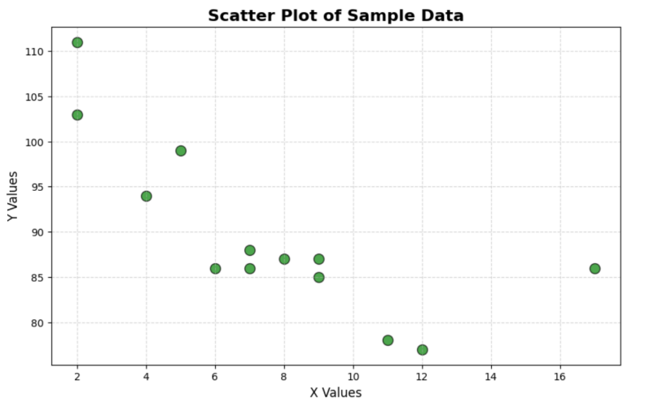

Import scipy and draw the line of Linear Regression:
import matplotlib.pyplot as plt
from scipy import stats
x = [5,7,8,7,2,17,2,9,4,11,12,9,6]
y = [99,86,87,88,111,86,103,87,94,78,77,85,86]
slope, intercept, r, p, std_err = stats.linregress(x, y)
def myfunc(x):
return slope * x + intercept
mymodel = list(map(myfunc, x))
plt.scatter(x, y)
plt.plot(x, mymodel)
plt.show()

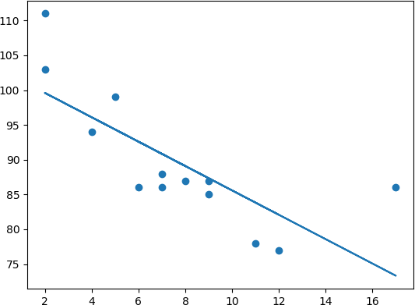
Output:

Logistic Regression in Machine Learning
• Logistic regression is one of the most popular Machine Learning algorithms, which comes under the Supervised Learning technique. It is used for predicting the categorical dependent variable using a given set of independent variables.
• Logistic regression predicts the output of a categorical dependent variable. Therefore, the outcome must be a categorical or discrete value. It can be either Yes or No, 0 or 1, true or False, etc. but instead of giving the exact value as 0 and 1, it gives the probabilistic values which lie between 0 and 1.
• Logistic Regression is much similar to the Linear Regression except that how they are used. Linear Regression is used for solving Regression problems, whereas Logistic regression is used for solving the classification problems.
• In Logistic regression, instead of fitting a regression line, we fit an "S" shaped logistic function, which predicts two maximum values (0 or 1).
• The curve from the logistic function indicates the likelihood of something such as whether the cells are cancerous or not, a mouse is obese or not based on its weight, etc.
• Logistic Regression is a significant machine learning algorithm because it has the ability to provide probabilities and classify new data using continuous and discrete datasets.
• Logistic Regression can be used to classify the observations using different types of data and can easily determine the most effective variables used for the classification. The below image is showing the logistic function:
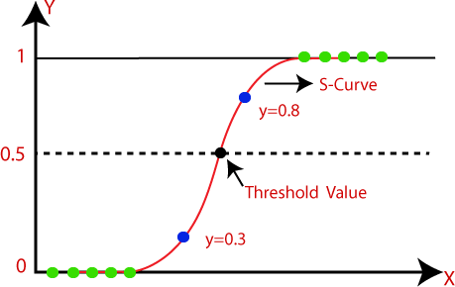

Logistic Regression Equation:
The Logistic regression equation can be obtained from the Linear Regression equation. The mathematical steps to get Logistic Regression equations are given below:
- We know the equation of the straight line can be written as:
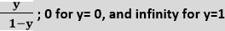
- In Logistic Regression y can be between 0 and 1 only, so for this let's divide the above equation by (1-y):

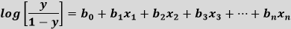
- But we need range between -[infinity] to +[infinity], then take logarithm of the equation it will become:

Decision Tree Classification Algorithm
- Decision Tree is a Supervised learning technique that can be used for both classification and Regression problems, but mostly it is preferred for solving Classification problems. It is a tree-structured classifier, where internal nodes represent the features of a dataset, branches represent the decision rules and each leaf node represents the outcome.
- In a Decision tree, there are two nodes, which are the Decision Node and Leaf Node. Decision nodes are used to make any decision and have multiple branches, whereas Leaf nodes are the output of those decisions and do not contain any further branches.
- The decisions or the test are performed on the basis of features of the given dataset.
- It is a graphical representation for getting all the possible solutions to a problem/decision based on given conditions.
- It is called a decision tree because, similar to a tree, it starts with the root node, which expands on further branches and constructs a tree-like structure.
- In order to build a tree, we use the CART algorithm, which stands for Classification and Regression Tree algorithm.
- A decision tree simply asks a question, and based on the answer (Yes/No), it further split the tree into subtrees.
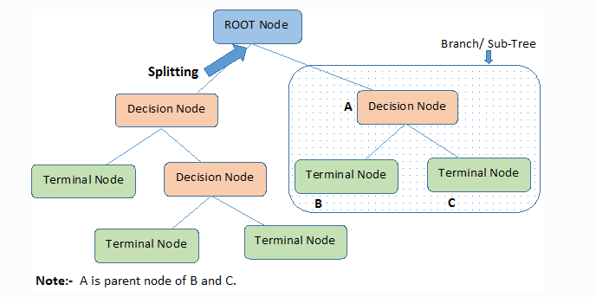
- Below diagram explains the general structure of a decision tree:

Support Vector Machine Algorithm
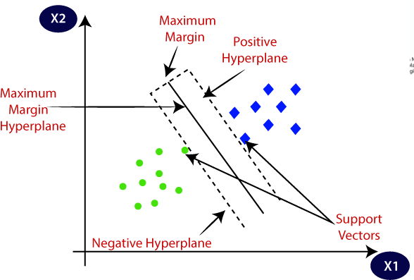
Support Vector Machine or SVM is one of the most popular Supervised Learning algorithms, which is used for Classification as well as Regression problems. However, primarily, it is used for Classification problems in Machine Learning. The goal of the SVM algorithm is to create the best line or decision boundary that can segregate n-dimensional space into classes so that we can easily put the new data point in the correct category in the future. This best decision boundary is called a hyperplane. SVM chooses the extreme points/vectors that help in creating the hyperplane. These extreme cases are called as support vectors, and hence algorithm is termed as Support Vector Machine. Consider the below diagram in which there are two different categories that are classified using a decision boundary or hyperplane
SVM can handle both linear and non-linear classification problems. Linear SVM is used when the data can be separated by a straight line or flat hyperplane. For non-linear problems, SVM uses the kernel trick to map the data into a higher-dimensional space where it becomes linearly separable. Common kernels include linear, polynomial, and radial basis function (RBF) kernels, each suited to different types of data distributions.
Unsupervised Machine Learning:
Unsupervised learning is a branch of machine learning that deals with unlabeled data. Unlike supervised learning, where the data is labeled with a specific category or outcome, unsupervised learning algorithms are tasked with finding patterns and relationships within the data without any prior knowledge of the data’s meaning. This makes unsupervised learning a powerful tool for exploratory data analysis, where the goal is to understand the underlying structure of the data.
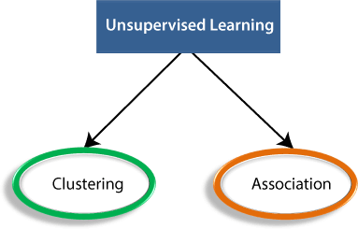
Example: Suppose the unsupervised learning algorithm is given an input dataset containing images of different types of cats and dogs. The algorithm is never trained upon the given dataset, which means it does not have any idea about the features of the dataset. The task of theunsupervised learning algorithm is to identify the image features on their own. Unsupervised learning algorithm will perform this task by clustering the image dataset into the groups according to similarities between images.
Types of Unsupervised Learning Algorithm:
The unsupervised learning algorithm can be further categorized into two types of problems:
- Clustering: Clustering is a method of grouping the objects into clusters such that objects with most similarities remains into a group and has less or no similarities with the objects of another group. Cluster analysis finds the commonalities between the data objects and categorizes them as per the presence and absence of those commonalities.
- Association: An association rule is an unsupervised learning method which is used for finding the relationships between variables in the large database. It determines the set of items that occurs together in the dataset. Association rule makes marketing strategy more effective. Such as people who buy X item (suppose a bread) are also tend to purchase Y (Butter/Jam) item. A typical example of Association rule is Market Basket Analysis.
Clustering Algorithms:
Clustering or cluster analysis is a machine learning technique, which groups the unlabelled dataset. It can be defined as "A way of grouping the data points into different clusters, consisting of similar data points. The objects with the possible similarities remain in a group that has less or no similarities with another group."

K-Means Clustering Algorithm
K-Means Clustering is an unsupervised learning algorithm that is used to solve the clustering problems in machine learning or data science. In this topic, we will learn what is K-means clustering algorithm, how the algorithm works, along with the Python implementation of k- means clustering.
What is K-Means Algorithm?
K-Means Clustering is an Unsupervised Learning algorithm, which groups the unlabelled dataset into different clusters. Here K defines the number of pre-defined clusters that need to be created in the process, as if K=2, there will be two clusters, and for K=3, there will be three clusters, and so on.
It is an iterative algorithm that divides the unlabelled dataset into k different clusters in such a way that each dataset belongs only one group that has similar properties.
It allows us to cluster the data into different groups and a convenient way to discover the categories of groups in the unlabelled dataset on its own without the need for any training.
It is a centroid-based algorithm, where each cluster is associated with a centroid. The main aim of this algorithm is to minimize the sum of distances between the data point and their corresponding clusters.
The algorithm takes the unlabelled dataset as input, divides the dataset into k-number of clusters, and repeats the process until it does not find the best clusters. The value of k should be predetermined in this algorithm.
The k-means clustering algorithm mainly performs two tasks:
- Determines the best value for K center points or centroids by an iterative process.
- Assigns each data point to its closest k-center. Those data points which are near to the particular k-center, create a cluster.
Hence each cluster has datapoints with some commonalities, and it is away from other clusters.

The below diagram explains the working of the K-means Clustering Algorithm:
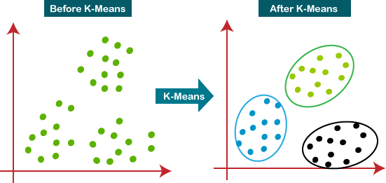
Hierarchical Clustering in Machine Learning
Hierarchical clustering is another unsupervised machine learning algorithm, which is used to group the unlabeled datasets into a cluster and also known as hierarchical cluster analysis or HCA.
In this algorithm, we develop the hierarchy of clusters in the form of a tree, and this tree-shaped structure is known as the dendrogram.
Sometimes the results of K-means clustering and hierarchical clustering may look similar, but they both differ depending on how they work. As there is no requirement to predetermine the number of clusters as we did in the K-Means algorithm.
The hierarchical clustering technique has two approaches:
- Agglomerative: Agglomerative is a bottom-up approach, in which the algorithm starts with taking all data points as single clusters and merging them until one cluster is left.
- Divisive: Divisive algorithm is the reverse of the agglomerative algorithm as it is a top- down approach.
Hierarchical Agglomerative Clustering
It is also known as the bottom-up approach or hierarchical agglomerative clustering (HAC). A structure that is more informative than the unstructured set of clusters returned by flat clustering. This clustering algorithm does not require us to prespecify the number of clusters.
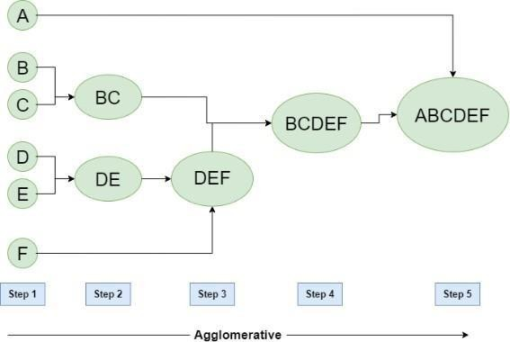
Bottom-up algorithms treat each data as a singleton cluster at the outset and then successively agglomerate pairs of clusters until all clusters have been merged into a single cluster that contains all data.

Hierarchical Divisive clustering
It is also known as a top-down approach. This algorithm also does not require prespecifying the number of clusters. Top-down clustering requires a method for splitting a cluster that contains the whole data and proceeds by splitting clusters recursively until individual data have been split into singleton clusters.
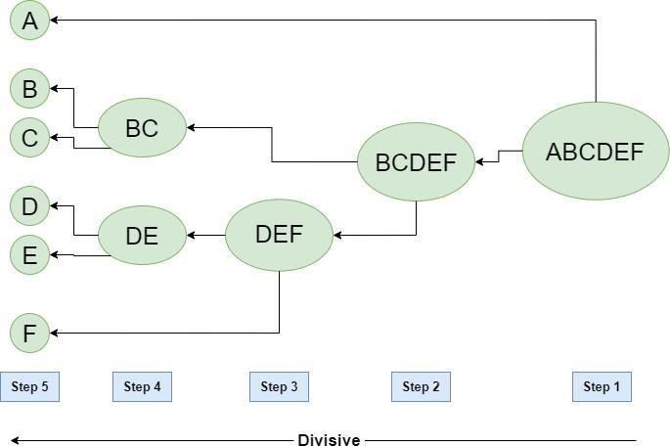

Dimensionality Reduction Techniques
The number of input features, variables, or columns present in a given dataset is known as dimensionality, and the process to reduce these features is called dimensionality reduction.
A dataset contains a huge number of input features in various cases, which makes the predictive modeling task more complicated. Because it is very difficult to visualize or make predictions for the training dataset with a high number of features, for such cases, dimensionality reduction techniques are required to use.
Dimensionality reduction technique can be defined as, "It is a way of converting the higher dimensions dataset into lesser dimensions dataset ensuring that it provides similar information." These techniques are widely used in machine learning for obtaining a better fit predictive model while solving the classification and regression problems.
It is commonly used in the fields that deal with high-dimensional data, such as speech recognition, signal processing, bioinformatics, etc. It can also be used for data visualization, noise reduction, cluster analysis, etc.
Benefits of applying Dimensionality Reduction
Some benefits of applying dimensionality reduction technique to the given dataset are given below:
- By reducing the dimensions of the features, the space required to store the dataset also gets reduced.
- Less Computation training time is required for reduced dimensions of features.
- Reduced dimensions of features of the dataset help in visualizing the data quickly.
- It removes the redundant features (if present) by taking care of multicollinearity.

Principal Component Analysis
Principal Component Analysis is an unsupervised learning algorithm that is used for the dimensionality reduction in machine learning. It is a statistical process that converts the observations of correlated features into a set of linearly uncorrelated features with the help of orthogonal transformation. These new transformed features are called the Principal Components. It is one of the popular tools that is used for exploratory data analysis and predictive modelling. It is a technique to draw strong patterns from the given dataset by reducing the variances. PCA generally tries to find the lower-dimensional surface to project the high-dimensional data.
PCA works by considering the variance of each attribute because the high attribute shows the good split between the classes, and hence it reduces the dimensionality. Some real-world applications of PCA are image processing, movie recommendation system, optimizing the power allocation in various communication channels. It is a feature extraction technique, so it contains the important variables and drops the least important variable.
The PCA algorithm is based on some mathematical concepts such as:
- Variance and Covariance
- Eigen values and Eigen factors
Some common terms used in PCA algorithm:
- Dimensionality: It is the number of features or variables present in the given dataset. More easily, it is the number of columns present in the dataset.
- Correlation: It signifies that how strongly two variables are related to each other. Such as if one changes, the other variable also gets changed. The correlation value ranges from -1 to +1. Here, -1 occurs if variables are inversely proportional to each other, and +1 indicates that variables are directly proportional to each other.
- Orthogonal: It defines that variables are not correlated to each other, and hence the correlation between the pair of variables is zero.
- Eigenvectors: If there is a square matrix M, and a non-zero vector v is given. Then v will be eigenvector if Av is the scalar multiple of v.
- Covariance Matrix: A matrix containing the covariance between the pair of variables is called the Covariance Matrix.

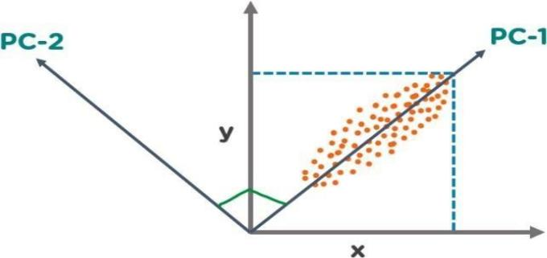
In the above figure, we have several points plotted on a 2-D plane. There are two principal components. PC1 is the primary principal component that explains the maximum variance in the data. PC2 is another principal component that is orthogonal to PC1.

Machine Learning Model Evaluation
Model evaluation is the process that uses some metrics which help us to analyse the performance of the model. As we all know that model development is a multi-step process and a check should be kept on how well the model generalizes future predictions. Therefore, evaluating a model plays a vital role so that we can judge the performance of our model. The evaluation also helps to analyse a model’s key weaknesses. There are many metrics like Accuracy, Precision, Recall, F1 score, Area under Curve, Confusion Matrix, and Mean Square Error. Cross Validation is one technique that is followed during the training phase and it is a model evaluation technique as well.
Cross Validation and Holdout
Cross Validation is a method in which we do not use the whole dataset for training. In this technique, some part of the dataset is reserved for testing the model. There are many types of Cross-Validation out of which K Fold Cross Validation is mostly used. In K Fold Cross Validation, the original dataset is divided into k subsets. The subsets are known as folds. This is repeated k times where 1-fold is used for testing purposes. Rest k-1 folds are used for training the model. So each data point acts as a test subject for the model as well as acts as the training subject. It is seen that this technique generalizes the model well and reduces the error rate
Holdout is the simplest approach. It is used in neural networks as well as in many classifiers. In this technique, the dataset is divided into train and test datasets. The dataset is usually divided into ratios like 70:30 or 80:20. Normally a large percentage of data is used for training the model and a small portion of the dataset is used for testing the model.
Evaluation Metrics for Classification Task
In this Python code, we have imported the iris dataset which has features like the length and width of sepals and petals. The target values are Iris setosa, Iris virginica, and Iris versicolor. After importing the dataset, we divided the dataset into train and test datasets in the ratio 80:20. Then we called Decision Trees and trained our model. After that, we performed the prediction and calculated the accuracy score, precision, recall, and f1 score. We also plotted the confusion matrix.
Importing Libraries and Dataset
Python libraries make it very easy for us to handle the data and perform typical and complex tasks with a single line of code.
- Pandas – This library helps to load the data frame in a 2D array format and has multiple functions to perform analysis tasks in one go.
- Numpy – Numpy arrays are very fast and can perform large computations in a very short time.
- Matplotlib/Seaborn – This library is used to draw visualizations.
- Sklearn – This module contains multiple libraries having pre-implemented functions to perform tasks from data preprocessing to model development and evaluation.

import pandas as pd
import numpy as np
from sklearn import tree from sklearn
import datasets from sklearn.datasets
import load_iris from sklearn.tree
import DecisionTreeClassifier
from sklearn.model_selection
import train_test_split
import seaborn as sns
import matplotlib.pyplot as plt
from sklearn.metrics import precision_score,\ recall_score, f1_score, accuracy_score
Now let’s load the toy dataset iris flowers from the sklearn.datasets library and then split it into training and testing parts (for model evaluation) in the 80:20 ratio.
- Python3

iris = load_iris()
X = iris.data
y = iris.target
# Holdout method.Dividing the data into train and test
X_train, X_test,\
y_train, y_test = train_test_split(X, y, random_state=20, test_size=0.20)

Now, let’s train a Decision Tree Classifier model on the training data, and then we will move on to the evaluation part of the model using different metrics.
- Python3
tree = DecisionTreeClassifier()
tree.fit(X_train, y_train)
y_pred = tree.predict(X_test)

Accuracy
Accuracy is defined as the ratio of the number of correct predictions to the total number of predictions. This is the most fundamental metric used to evaluate the model. The formula is given by
Accuracy = (TP+TN)/(TP+TN+FP+FN)
However, Accuracy has a drawback. It cannot perform well on an imbalanced dataset. Suppose a model classifies that the majority of the data belongs to the major class label. It yields higher accuracy. But in general, the model cannot classify on minor class labels and has poor performance.
- Python3
print("Accuracy:", accuracy_score(y_test, y_pred))
Output: Accuracy: 0.9333333333333333
Precision and Recall
Precision is the ratio of true positives to the summation of true positives and false positives. It basically analyses the positive predictions.
Precision = TP/(TP+FP)
The drawback of Precision is that it does not consider the True Negatives and False Negatives.
Recall is the ratio of true positives to the summation of true positives and false negatives. It basically analyses the number of correct positive samples.
Recall = TP/(TP+FN)
The drawback of Recall is that often it leads to a higher false positive rate.
- Python3
print("Precision:", precision_score(y_test, y_pred, average="weighted"))
print('Recall:', recall_score(y_test, y_pred, average="weighted"))
Output:
Precision: 0.9435897435897436
Recall: 0.9333333333333333
F1 score
The F1 score is the harmonic mean of precision and recall. It is seen that during the precision- recall trade-off if we increase the precision, recall decreases and vice versa. The goal of the F1 score is to combine precision and recall.
F1 score = (2×Precision×Recall)/(Precision+Recall)
- Python3
# calculating f1 score
print('F1 score:', f1_score(y_test, y_pred, average="weighted"))

Output:
F1 score: 0.9327777777777778

Confusion Matrix
A confusion matrix is an N x N matrix where N is the number of target classes. It represents the number of actual outputs and the predicted outputs. Some terminologies in the matrix are as follows:
- True Positives: It is also known as TP. It is the output in which the actual and the predicted values are YES.
- True Negatives: It is also known as TN. It is the output in which the actual and the predicted values are NO.
- False Positives: It is also known as FP. It is the output in which the actual value is NO but the predicted value is YES.
- False Negatives: It is also known as FN. It is the output in which the actual value is YES but the predicted value is NO.
- Python3

confusion_matrix = metrics.confusion_matrix(y_test, y_pred)
cm_display = metrics.ConfusionMatrixDisplay( confusion_matrix=confusion_matrix,display_labels=[0, 1, 2])
cm_display.plot()
plt.show()

Output:
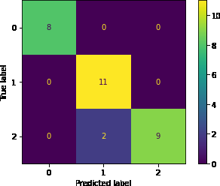

Evaluation Metrics for Regression Task
Regression is used to determine continuous values. It is mostly used to find a relation between a dependent and an independent variable. For classification, we use a confusion matrix, accuracy, f1 score, etc. But for regression analysis, since we are predicting a numerical value it may differ from the actual output. So we consider the error calculation as it helps to summarize how close the prediction is to the actual value. There are many metrics available for evaluating the regression model.
In this Python Code, we have implemented a simple regression model using the Mumbai weather CSV file. This file comprises Day, Hour, Temperature, Relative Humidity, Wind Speed, and Wind Direction. We are basically interested in finding a relationship between Temperature and Relative Humidity. Here Relative Humidity is the dependent variable and Temperature is the independent variable. We performed the Linear Regression and used the metrics to evaluate the performance of our model. To calculate the metrics, we make extensive use of sklearn library.
Several evaluation metrics are commonly used in regression tasks. Mean Absolute Error (MAE) calculates the average of absolute differences between predicted and actual values, giving a straightforward interpretation of the prediction error. Mean Squared Error (MSE) squares the differences before averaging, which penalizes larger errors more heavily, making it sensitive to outliers. Root Mean Squared Error (RMSE) is the square root of MSE and represents the standard deviation of prediction errors, providing a metric in the same units as the target variable. Another useful metric is R-squared (R²), which measures how well the regression model explains the variability of the dependent variable; values closer to 1 indicate a better fit.
Python’s scikit-learn (sklearn) library provides convenient functions to implement regression models and calculate evaluation metrics. After training a regression model, functions such as mean_absolute_error, mean_squared_error, and r2_score allow developers to quickly evaluate how well the model predicts unseen data. Using these metrics, we can fine-tune the model, detect issues such as overfitting or underfitting, and ensure that the regression predictions are accurate and reliable.
In regression analysis, unlike classification, traditional metrics such as accuracy, F1-score, or confusion matrices are not applicable because the predictions are continuous values. Instead, we focus on error-based metrics that measure how close the predicted values are to the actual values. Evaluating these errors helps in understanding the performance and reliability of the regression model and in comparing different models for the same dataset.

# importing the libraries
from sklearn.linear_model import LinearRegression

from sklearn.metrics import mean_absolute_error,\

mean_squared_error, mean_absolute_percentage_error

Now let’s load the data into the panda’s data frame and then split it into training and testing parts (for model evaluation) in the 80:20 ratio.

df = pd.read_csv('weather.csv')

X = df.iloc[:, 2].values

Y = df.iloc[:, 3].values

X_train, X_test,\

Y_train, Y_test = train_test_split(X, Y, test_size=0.20,random_state=0)

Now, let’s train a simple linear regression model. On the training data and we will move to the evaluation part of the model using different metrics.

- Python3

X_train = X_train.reshape(-1, 1)

X_test = X_test.reshape(-1, 1)

regression = LinearRegression()

regression.fit(X_train, Y_train)

Y_pred = regression.predict(X_test)

Mean Absolute Error (MAE)

This is the simplest metric used to analyze the loss over the whole dataset. As we all know the error is basically the difference between the predicted and actual values. Therefore, MAE is defined as the average of the errors calculated. Here we calculate the modulus of the error, perform the summation and then divide the result by the number of data points. It is a positive quantity and is not concerned about the direction. MAE provides a clear and interpretable measure of average error in the same units as the target variable. A lower MAE indicates that the model’s predictions are close to the actual values, while a higher MAE signals poorer performance. In practical scenarios, such as predicting Relative Humidity from Temperature in the Mumbai weather dataset, MAE is often used alongside metrics like MSE and R² to give a comprehensive view of model accuracy and reliability. The formula of MAE is given by

MAE = Σ|ypred-yactual| / N

  - Python3

mae = mean_absolute_error(y_true=Y_test, y_pred=Y_pred)

print("Mean Absolute Error", mae)

Output:

Mean Absolute Error 1.7236295632503873

Mean Squared Error (MSE)

The most commonly used metric is Mean Square error or MSE. It is a function used to calculate the loss. We find the difference between the predicted values and the truth variable, square the result and then find the average over the whole dataset. MSE is always positive as we square the values. The small the MSE better is the performance of our model. MSE is particularly useful in model comparison and optimization because it provides a clear numerical value representing the average magnitude of errors. Lower MSE values indicate that the model’s predictions are closer to the actual values, while higher MSE values suggest poor predictive performance. The formula of MSE is given:

MSE = Σ(ypred - yactual)2 / N

  - Python3

mse = mean_squared_error(y_true=Y_test, y_pred=Y_pred)

print("Mean Square Error", mse)
Output:

Mean Square Error 3.9808057060106954

Root Mean Squared Error (RMSE)

RMSE is a popular method and is the extended version of MSE (Mean Squared Error). This method is basically used to evaluate the performance of our model. It indicates how much the data points are spread around the best line. It is the standard deviation of the Mean squared error. A lower value means that the data point lies closer to the best fit line.

RMSE=√(Σ(ypred - yactual)2 / N)

  - Python3

rmse = mean_squared_error(y_true=Y_test, y_pred=Y_pred, squared=False)

print("Root Mean Square Error", rmse)

Output:

Root Mean Square Error 1.9951956560725306

Fundamentals of Deep Learning:

Deep learning is based on the branch of machine learning, which is a subset of artificial intelligence. Since neural networks imitate the human brain and so deep learning will do. In deep learning, nothing is programmed explicitly. Basically, it is a machine learning class that makes use of numerous nonlinear processing units so as to perform feature extraction as well as transformation. The output from each preceding layer is taken as input by each one of the successive layers.

Deep learning models are capable enough to focus on the accurate features themselves by requiring a little guidance from the programmer and are very helpful in solving out the problem of dimensionality. Deep learning algorithms are used, especially when we have a huge no of inputs and outputs.

Deep learning is a collection of statistical techniques of machine learning for learning feature hierarchies that are actually based on artificial neural networks.
So basically, deep learning is implemented by the help of deep networks, which are nothing but neural networks with multiple hidden layers.
The key strengths of deep learning include its ability to handle large-scale and high-dimensional data, automatically extract features, and achieve high accuracy in complex tasks. However, deep learning models require large amounts of labeled data, significant computational resources, and careful tuning of hyperparameters to perform effectively.

Example of Deep Learning
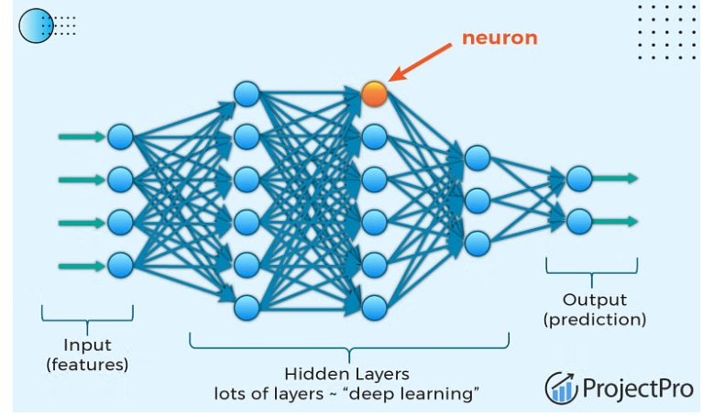

In the example given above, we provide the raw data of images to the first layer of the input layer. After then, these input layer will determine the patterns of local contrast that means it will differentiate on the basis of colors, luminosity, etc. Then the 1st hidden layer will determine the face feature, i.e., it will fixate on eyes, nose, and lips, etc. And then, it will fixate those face features on the correct face template. So, in the 2nd hidden layer, it will actually determine the correct face here as it can be seen in the above image, after which it will be sent to the output layer. Likewise, more hidden layers can be added to solve more complex problems, for example, if you want to find out a particular kind of face having large or light complexions. So, as and when the hidden layers increase, we are able to solve complex problems.

Types of Neural Networks:

- Feed Forward Neural Network

A feed-forward neural network is none other than an Artificial Neural Network, which ensures that the nodes do not form a cycle. In this kind of neural network, all the perceptrons are organized within layers, such that the input layer takes the input, and the output layer generates the output. Since the hidden layers do not link with the outside world, it is named as hidden layers. Each of the perceptrons contained in one single layer is associated with each node in the subsequent layer. It can be concluded that all of the nodes are fully connected. It does not contain any visible or invisible connection between the nodes in the same layer. There are no back-loops in the feed- forward network. To minimize the prediction error, the backpropagation algorithm can be used to update the weight values.
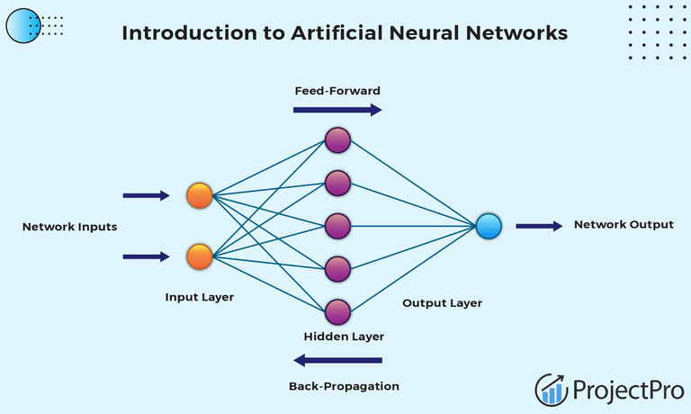

- Recurrent Neural Network

Recurrent neural networks are yet another variation of feed-forward networks. Here each of the neurons present in the hidden layers receives an input with a specific delay in time. The Recurrent neural network mainly accesses the preceding info of existing iterations. For example, to guess the succeeding word in any sentence, one must have knowledge about the words that were previously used. It not only processes the inputs but also shares the length as well as weights crossways time. It does not let the size of the model to increase with the increase in the input size. However, the only problem with this recurrent neural network is that it has slow computational speed as well as it does not contemplate any future input for the current state. It has a problem with reminiscing prior information.
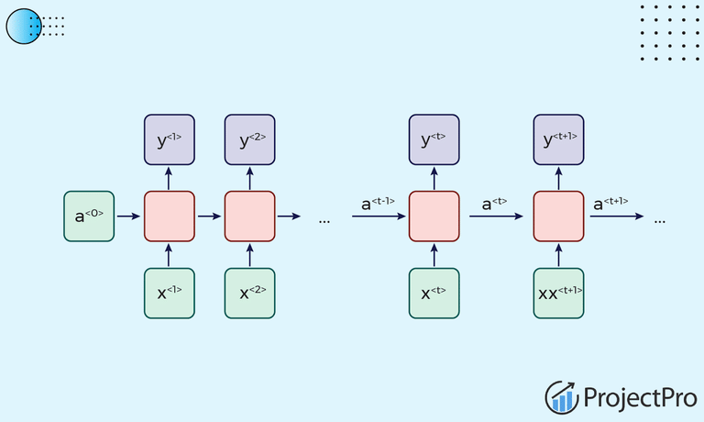

3.Convolutional Neural Network

  - Convolutional Neural Networks are a special kind of neural network mainly used for image classification, clustering of images and object recognition. DNNs enable unsupervised construction of hierarchical image representations. To achieve the best accuracy, deep convolutional neural networks are preferred more than any other neural network.
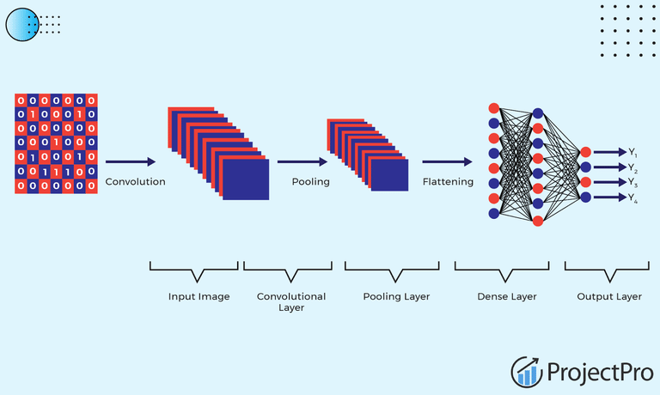

4.Restricted Boltzmann Machine

RBMs are yet another variant of Boltzmann Machines. Here the neurons present in the input layer and the hidden layer encompasses symmetric connections amid them. However, there is no internal association within the respective layer. But in contrast to RBM, Boltzmann machines do encompass internal connections inside the hidden layer. These restrictions in BMs helps the model to train efficiently.

5.Autoencoders
An autoencoder neural network is another kind of unsupervised machine learning algorithm. Here the number of hidden cells is merely small than that of the input cells. But the number of input cells is equivalent to the number of output cells. An autoencoder network is trained to display the output similar to the fed input to force AEs to find common patterns and generalize the data. The autoencoders are mainly used for the smaller representation of the input. It helps in the reconstruction of the original data from compressed data. This algorithm is comparatively simple as it only necessitates the output identical to the input.

- Encoder: Convert input data in lower dimensions.
- Decoder: Reconstruct the compressed data.
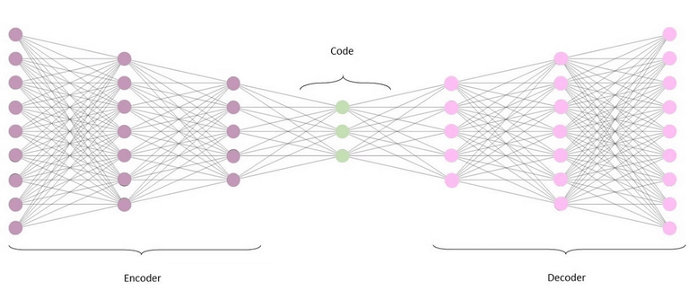

CHAPTER-4

PROPOSED METHODOLOGY

Project Title: Language Detection Model Using Machine Learning Models

Executive Summary

The project aims to develop a language detection model using machine learning techniques in Python. Language detection is a crucial task, especially in multilingual environments like the internet, where content needs to be processed and understood accurately. With the abundance of data available today, machine learning models can effectively identify languages with high accuracy. This project utilizes a dataset containing 1000 sentences from 22 popular languages to train a Multinomial Naïve Bayes classifier. The trained model achieves an accuracy of approximately 95.3% on the test data, demonstrating its effectiveness in language detection.

Introduction

4.1 Background

Language detection is vital for various applications, including multilingual search engines, content filtering, and translation services. Traditional rule-based approaches for language identification have limitations, particularly when dealing with noisy or ambiguous text. Machine learning offers a more robust solution by automatically learning patterns and features from data. With the availability of large datasets containing diverse linguistic samples, training accurate language detection models has become feasible.

  - Problem Statement

The project addresses the challenge of accurately detecting the language of a given text input. The goal is to develop a machine learning model capable of distinguishing between multiple languages with high precision and recall. The model should be able to handle real-world text inputs from various sources and provide reliable language identification results.

Project Scope

The scope of the project includes importing necessary libraries, loading the dataset, preprocessing the data, training a machine learning model, testing the model's performance, and implementing a user interface for real-time Language Detection.

Methodology:

The methodology involves:

  - Importing the required libraries.
  - Loading the dataset containing message content and labels.
  - Preprocessing the data by selecting relevant features and splitting the dataset into training and testing sets.
  - Training a machine learning model (Multinomial Naïve Bayes in this case) on the training data.
  - Evaluating the model's performance using test data.
  - Implementing a user interface to input messages and predict whether they are spam or not.

Project Planning: The project plan may include defining tasks, setting milestones, allocating resources, and
estimating timelines for each phase of the project, such as data preparation, model training, testing, and deployment.

Project Execution: The execution phase involves implementing the planned tasks, including coding, testing, debugging, and iterating to improve the model's performance and user interface.

System Design: The system design encompasses the architecture and components of the spam detection system, including data preprocessing, feature extraction, model training, prediction, and user interface implementation. It also involves considering scalability, efficiency, and usability aspects.

Spam Detection Implementation

- Importing Libraries and Dataset: The necessary libraries like pandas, numpy, and scikit- learn are imported. The dataset is loaded from a CSV file using pandas.

- Preprocessing: The dataset is pre-processed to select only the necessary columns (‘Language’).

- Feature Extraction: The messages are converted into numerical features using the CountVectorizer from scikit-learn. This step converts the text data into a matrix of token counts.

- Splitting the Data: The dataset is split into training and testing sets using train_test_split from scikit-learn.

- Training the Model: A Multinomial Naive Bayes classifier is instantiated and trained on the training data.

- Testing the Model: The model is tested on a user input message to predict which language is it in the dataset.

Python Code:

import pandas as pd
import numpy as np
from sklearn.feature_extraction.text import CountVectorizer
from sklearn.model_selection import train_test_split
from sklearn.naive_bayes import MultinomialNB

# Load the dataset
data = pd.read_csv("https://raw.githubusercontent.com/amankharwal/Website-data/master/dataset.csv")

# Display first few rows
print(data.head())

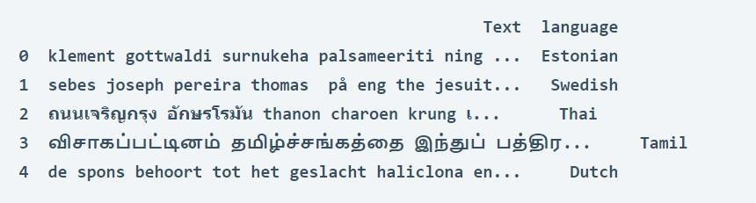
Output:

# Check for null values
print("Null values in each column:\n", data.isnull().sum())

# Display language counts
print("\nLanguage distribution:\n", data["language"].value_counts())

# Split data into features and labels
x = np.array(data["Text"])
y = np.array(data["language"])

# Text vectorization
cv = CountVectorizer()
X = cv.fit_transform(x)

# Train-test split
X_train, X_test, y_train, y_test = train_test_split(X, y, test_size=0.33, random_state=42)

# Train the model
model = MultinomialNB()
model.fit(X_train, y_train)

# Evaluate model
accuracy = model.score(X_test, y_test)
print("\nModel Accuracy:", accuracy)

# Predict language for user input
user_input = input("\nEnter a Text: ")
user_data = cv.transform([user_input]).toarray()
output = model.predict(user_data)

print("Predicted Language:", output[0])

Output:

Enter a Text: दे खकर अच्छा लगता है

['Hindi']

CHAPTER-5

RESULTS AND CONCLUSION

Result

- The language detection project aimed to develop and implement a machine learning-based software application capable of identifying and categorizing text data into different languages. By leveraging machine learning algorithms, the project aimed to accurately determine the language of input text, enabling various applications such as multilingual support, content filtering, and data analysis.
- Through rigorous testing and iterative refinement, the project team successfully created a robust language detection system. The system utilizes machine learning algorithms to analyse textual data and identify distinctive patterns associated with different languages.
- The outcomes of the project have significant implications for various industries and applications. By implementing the language detection system, organizations can enhance their capabilities in multilingual content analysis, customer support, and internationalization efforts.
- The language detection project contributes to improving data processing efficiency, enabling more effective communication and analysis across diverse linguistic contexts. Furthermore, by promoting the adoption of language detection technology, the project aims to raise awareness about the importance of linguistic diversity and the need for inclusive communication platforms.

Conclusion of BIST Technologies Internship

The BIST Technologies internship has been a valuable and enriching experience, providing an opportunity for personal and professional growth. Over the course of this internship, I have had the chance to work on a variety of projects, collaborate with talented colleagues, and gain insights into the dynamics of the workplace. Here, I summarize the key takeaways and express my gratitude for this opportunity.

- Skill Development: The internship at BIST has allowed me to further develop and apply the skills I acquired during my academic studies. I have gained hands-on experience in areas such as project management, data analysis, programming, and problem-solving. The practical knowledge I've acquired is an invaluable asset for my future career.

- Teamwork and Collaboration: Working alongside a diverse and dedicated team has taught me the importance of effective communication and collaboration. I have had the privilege of contributing to team projects, sharing ideas, and learning from the expertise of my colleagues. This experience has reinforced the significance of teamwork in achieving common goals.
- Adaptability and Innovation: The dynamic and ever-evolving nature of the projects at BIST has encouraged adaptability and innovation. I have learned to embrace change, think creatively, and find solutions to complex challenges. These qualities will serve me well in any future endeavour.
- Professional Growth: The internship has provided me with insights into the professional world, allowing me to understand the expectations, work ethics, and standards of the industry. I have gained confidence in my abilities and a clearer sense of my career goals.
- Networking and Mentorship: The connections I have made with professionals in the field have been invaluable. The guidance and mentorship provided by experienced individuals at BIST have been instrumental in shaping my career aspirations and choices.

In conclusion, my time at BIST Technologies has been a transformative experience. It has not only enriched my technical skills but also fostered personal and professional growth. I am grateful for the trust and support I received from the team and management during my internship. I look forward to applying the knowledge and experience I have gained here to future opportunities and challenges.

I extend my sincere gratitude to the entire BIST team for this incredible experience. Thank youfor the knowledge, the friendships, and the growth opportunities. This internship has been an invaluable chapter in my professional development, and I am excited to carry the lessons and experiences with me as I embark on the next phase of my career.

CHAPTER-6

VERIFIABLE CREDIENTIALS



📂 GitHub Repository:

https://github.com/harshi600211-collab/movie-recommendation-system

References

- Dataset for Language Detection. Available at: https://raw.githubusercontent.com/amankharwal/Website-data/master/dataset.csv
- Jupyter, Project. Jupyter Notebook: Open Source Web Application for Interactive Computing. Available at: https://jupyter.org
- The Pandas Development Team. Pandas Documentation. Available at: https://pandas.pydata.org
- The Scikit-learn Developers. Scikit-learn User Guide. Available at: https://scikit-learn.org/stable/
- Miryala, Goutham. A Comparative Study of ALS and Other Algorithms for Movie Recommendation Systems. International Journal of Computer Applications, 2021.
- Cui, Bei-Bei. Design and Implementation of Collaborative Filtering Approach Using KNN for Movie Recommendation Systems. IEEE Access, 2020.
- McKinney, Wes. Python for Data Analysis: Data Wrangling with Pandas, NumPy, and IPython. O’Reilly Media, 2018.
- Géron, Aurélien. Hands-On Machine Learning with Scikit-Learn, Keras, and TensorFlow. 3rd ed., O’Reilly Media, 2023.
- Pedregosa, F. et al. Scikit-learn: Machine Learning in Python. Journal of Machine Learning Research, Vol. 12, 2011, pp. 2825-2830.
- Chollet, François. Deep Learning with Python. 2nd ed., Manning Publications, 2021.

